**‘Care Share**



March 2022

Recently we’ve received questions about Medicare Flex Cards and genetic test kits being advertised on Facebook. Before addressing that specifically we need to talk about protecting yourself on social media from scams in general. As social media grows, so do the scams. If you use Facebook, you’ve probably already recognized this. The ads are everywhere.

Since Facebook earns the bulk of its revenue from sponsored ads, they aren’t going to go away either. Instead of worrying about if or when you will fall victim, take steps now to understand the risks and the ways to protect yourself and then sit back and enjoy staying in touch with your friends and family.

The #1 tip to staying ahead of the ads that aren’t legitimate is to understand that a legitimate sponsored ad will have the word “sponsored” above it. If you see something that looks like an ad but doesn’t have the word “sponsored” above it, it is a scam 100% of the time.

Now that you can recognize the obvious scams, from there you need to look at the sponsored ads. A sponsored ad on Facebook can also be fraudulent or misleading, only someone paid Facebook to post it.

Facebook does a good job of vetting ahead of time, but for those who slip through, here are a few things to keep in mind.

As always, if it sounds too good to be true…I probably don’t need to finish this sentence.

If you still want to check it out, don’t click on the ad as you’ll probably be taken to a fraudulent website that could steal your personal information including credit card info, plus could download malware onto your device.

Instead, if you are interested in the item, search online, and go to the website separately. And even then, a good practice if you have any suspicions is to type the name plus “scam” or “complaint” in the search engine and see if there is anything there.

In addition to the ads, the Federal Trade Commission warns that scammers can hide behind phony profiles on social media. They can take over an account or join a virtual community you trust to encourage you to trust them. But you can make it harder for scammers to target you:

Review your social media privacy settings and limit what you share publicly.

If someone appears on your social media and rushes you to start a friendship or romance, slow down. Read about romance scams.

If you get a message from a friend about a grant or financial relief, call them. Did they really send that message? If not, their account may have been hacked. Check it out before you act.

**If you spot a scam, report it to the social media site and the FTC at ftc.gov/complaint.**

Back to the flex cards and genetic test kits. Advertisements for Medicare-supplied flex cards offering things as up to $2,880 are in fact a bit misleading. Medicare is not distributing flex cards for seniors, and it is not a government-run program.

Private Medicare Advantage plans do offer this benefit; however, you would need to be on the plan to receive it. Not only that, but the average benefit amounts to $500 and is to be used for qualifying medical expenses as part of your benefits package. Also, flex cards are not available in every state, and not available with every plan. If you are interested in joining a Medicare Advantage Plan, **talk to a local SHIP Counselor by calling 1-800-551-3191, or go to Medicare.gov** and compare plans.

Regarding the genetic test kits, the best advice is to always talk to your doctor. Though genetic test kits and cardiac test kits are a legitimate service, scammers are out to bill Medicare for unnecessary tests. This con can lead to medical identity theft in addition to a possible bill for the cost of the unnecessary test.

For all scams, whether it be on social media, the phone, email or other, keep one step ahead by understanding the latest scams and understanding the steps you can take to protect yourself.

**For Medicare fraud information including to report unsolicited genetic or cardiac test kits, contact your local MT SMP office at 1-800-551-3191.**

**Social Media Scams Increasing**

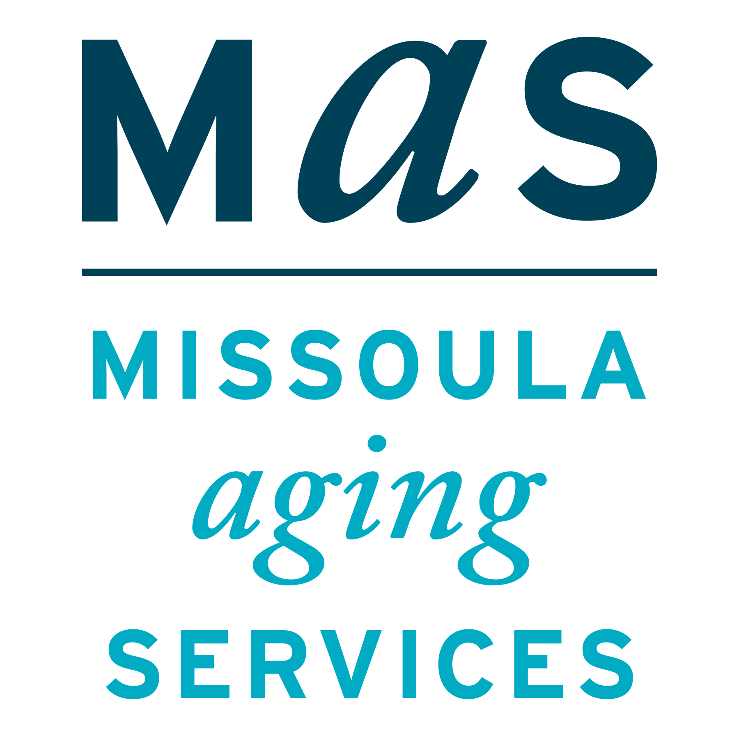



Montana SMP is a program coordinated by Missoula Aging Services and partnered with local Area Agencies on Aging. This project was supported by grant #90MPPG0052 from the U.S. Administration for Community Living, Department of Health and Human Services, Washington D.C., 20201. Points of view or opinions do not necessarily represent official ACL policy.

# National Slam the Scam Day Approaching on March 10

Consumers lost hundreds of millions of dollars to government imposter scams last year alone

For more information, check out resources at oig.ssa.gov

The Senior Medicare Patrol (SMP) helps to educate Medicare beneficiaries about ways to prevent, detect, and combat Medicare fraud. For more information about Medicare fraud, visit the Stop Medicare Fraud website at www.stopmedicarefraud.org.

