**‘Care Share**



February 2022

Why do I keep getting robocalls? I’m receiving even MORE spam calls during the pandemic! I’m on the Do Not Call List (state and federal) ---why doesn’t that help?

We frequently hear these frustrations from older adults and their families when they call to report a healthcare or consumer fraud scam.

We tell them to “SCREEN ALL CALLS - don’t pick up any call unless you’re sure it’s from someone you know”. But we also realize there are valid reasons to pick up that phone. For instance, everyone looks forward to calls from friends and family; we may be waiting for return calls from medical professionals or businesses like the mechanic; and it could be someone with dementia who will answer all calls. Further, the telephone has been a lifeline and safe way to stay connected for those stuck at home during the pandemic.

So, what’s the answer? It can be complicated.

The Federal Trade Commission (FTC) shared this blog on *How to Stop Unwanted Calls,* <https://www.consumer.ftc.gov/articles/how-block-unwanted-calls#landlineblock>. You will learn about blocking or screening calls by reading the blog.

The telephone of today is not the same phone that used to hang on our kitchen wall. The following are some suggested Do’s and Don’ts for our phones of today:

* Do learn the terminology! (i.e., call blocking, screening, labeling, spoofing, etc.)
* Do learn what type of phone you have, i.e., VoIP landline, traditional landline, smart or dumb mobile phone. Options for blocking and screening vary upon the type of phone and your carrier. Some are free and some have an associated fee.
* Do consider upgrading to a “smart” phone so you can use mobile apps to help block and screen calls. Smart phones have blocking features built into the phone.
* Do check with your telephone carrier to see what call blocking, caller ID/labeling and/or screening services it offers. Some block potential scam calls, some flag suspicious calls and some screen, label, or filter calls.
* Do check with trusted resources like the local area agency on aging if you want to know more about the caller’s proposal or offer. They can help you ferret out likely scams.
* Do report scam calls to the FTC at [reportfraud.ftc.gov/#/](https://reportfraud.ftc.gov/#/) or 1-877-FTC-HELP.
* Do list your number on the state and local Do Not Call Registry.
* Do install a call blocking device if your carrier does not offer any service that you like or can afford.
* Don’t keep answering the phone! The more you pick up (even if you hang-up), the more calls you will receive, because they sell lists of working numbers and answering the phone will mark you as a live line.
* Don’t act under pressure! Many scammers tell you that you must “act now” or your services or benefits will be terminated.
* Don’t “press 1” to get off the call list as the number may sell for a higher price because you follow directions.
* Don’t yell, argue, engage, or blow a whistle into the phone. Again, if you engage in any way, that increases the likelihood of your number being sold.
* Don’t take action from an unsolicited caller. To learn more, call the entity by looking up the number separately, or call a trusted community resource.

According to AARP’s The Con Artists Playbook, every 2 seconds a con artist steals someone’s identity. AARP MT provides various resources to help you stay ahead of the curve. For more information call 877-908-3360. If you need more information or to report Medicare and healthcare fraud, contact MT SMP at   
1-800-551-3191.

**More Resources**

* If you encounter a suspected phone scam or an abusive telemarketer, file a complaint with the Federal Trade Commission, [online](https://www.ftc.gov/complaint) or at 877-382-4357, and notify your [state consumer protection office](https://www.usa.gov/state-consumer).
* Report caller-ID spoofing to the Federal Communications Commission, [online](https://consumercomplaints.fcc.gov/hc/en-us) or at 888-225-5322. The FCC also provides [consumer guides](https://www.fcc.gov/general/frauds-scams-and-alerts-guides#block-menu-block-4) to numerous phone scams and improper practices.
* Visit the Do Not Call Registry [website](http://www.donotcall.gov/) or call 888-382-1222 to register your number or report illegal robocalls.

**Scam Alert:   
This scam is active in Montana.**

Scammers are offering Medicare beneficiaries cheek swabs for genetic testing to obtain their Medicare information for fraudulent billing purposes or possibly medical identity theft.

If you have received such a call and given out information, or received paperwork to fill out, please contact your MT SMP at 1-800-551-3191 today.

**Don’t be Afraid to Just…Block Calls**

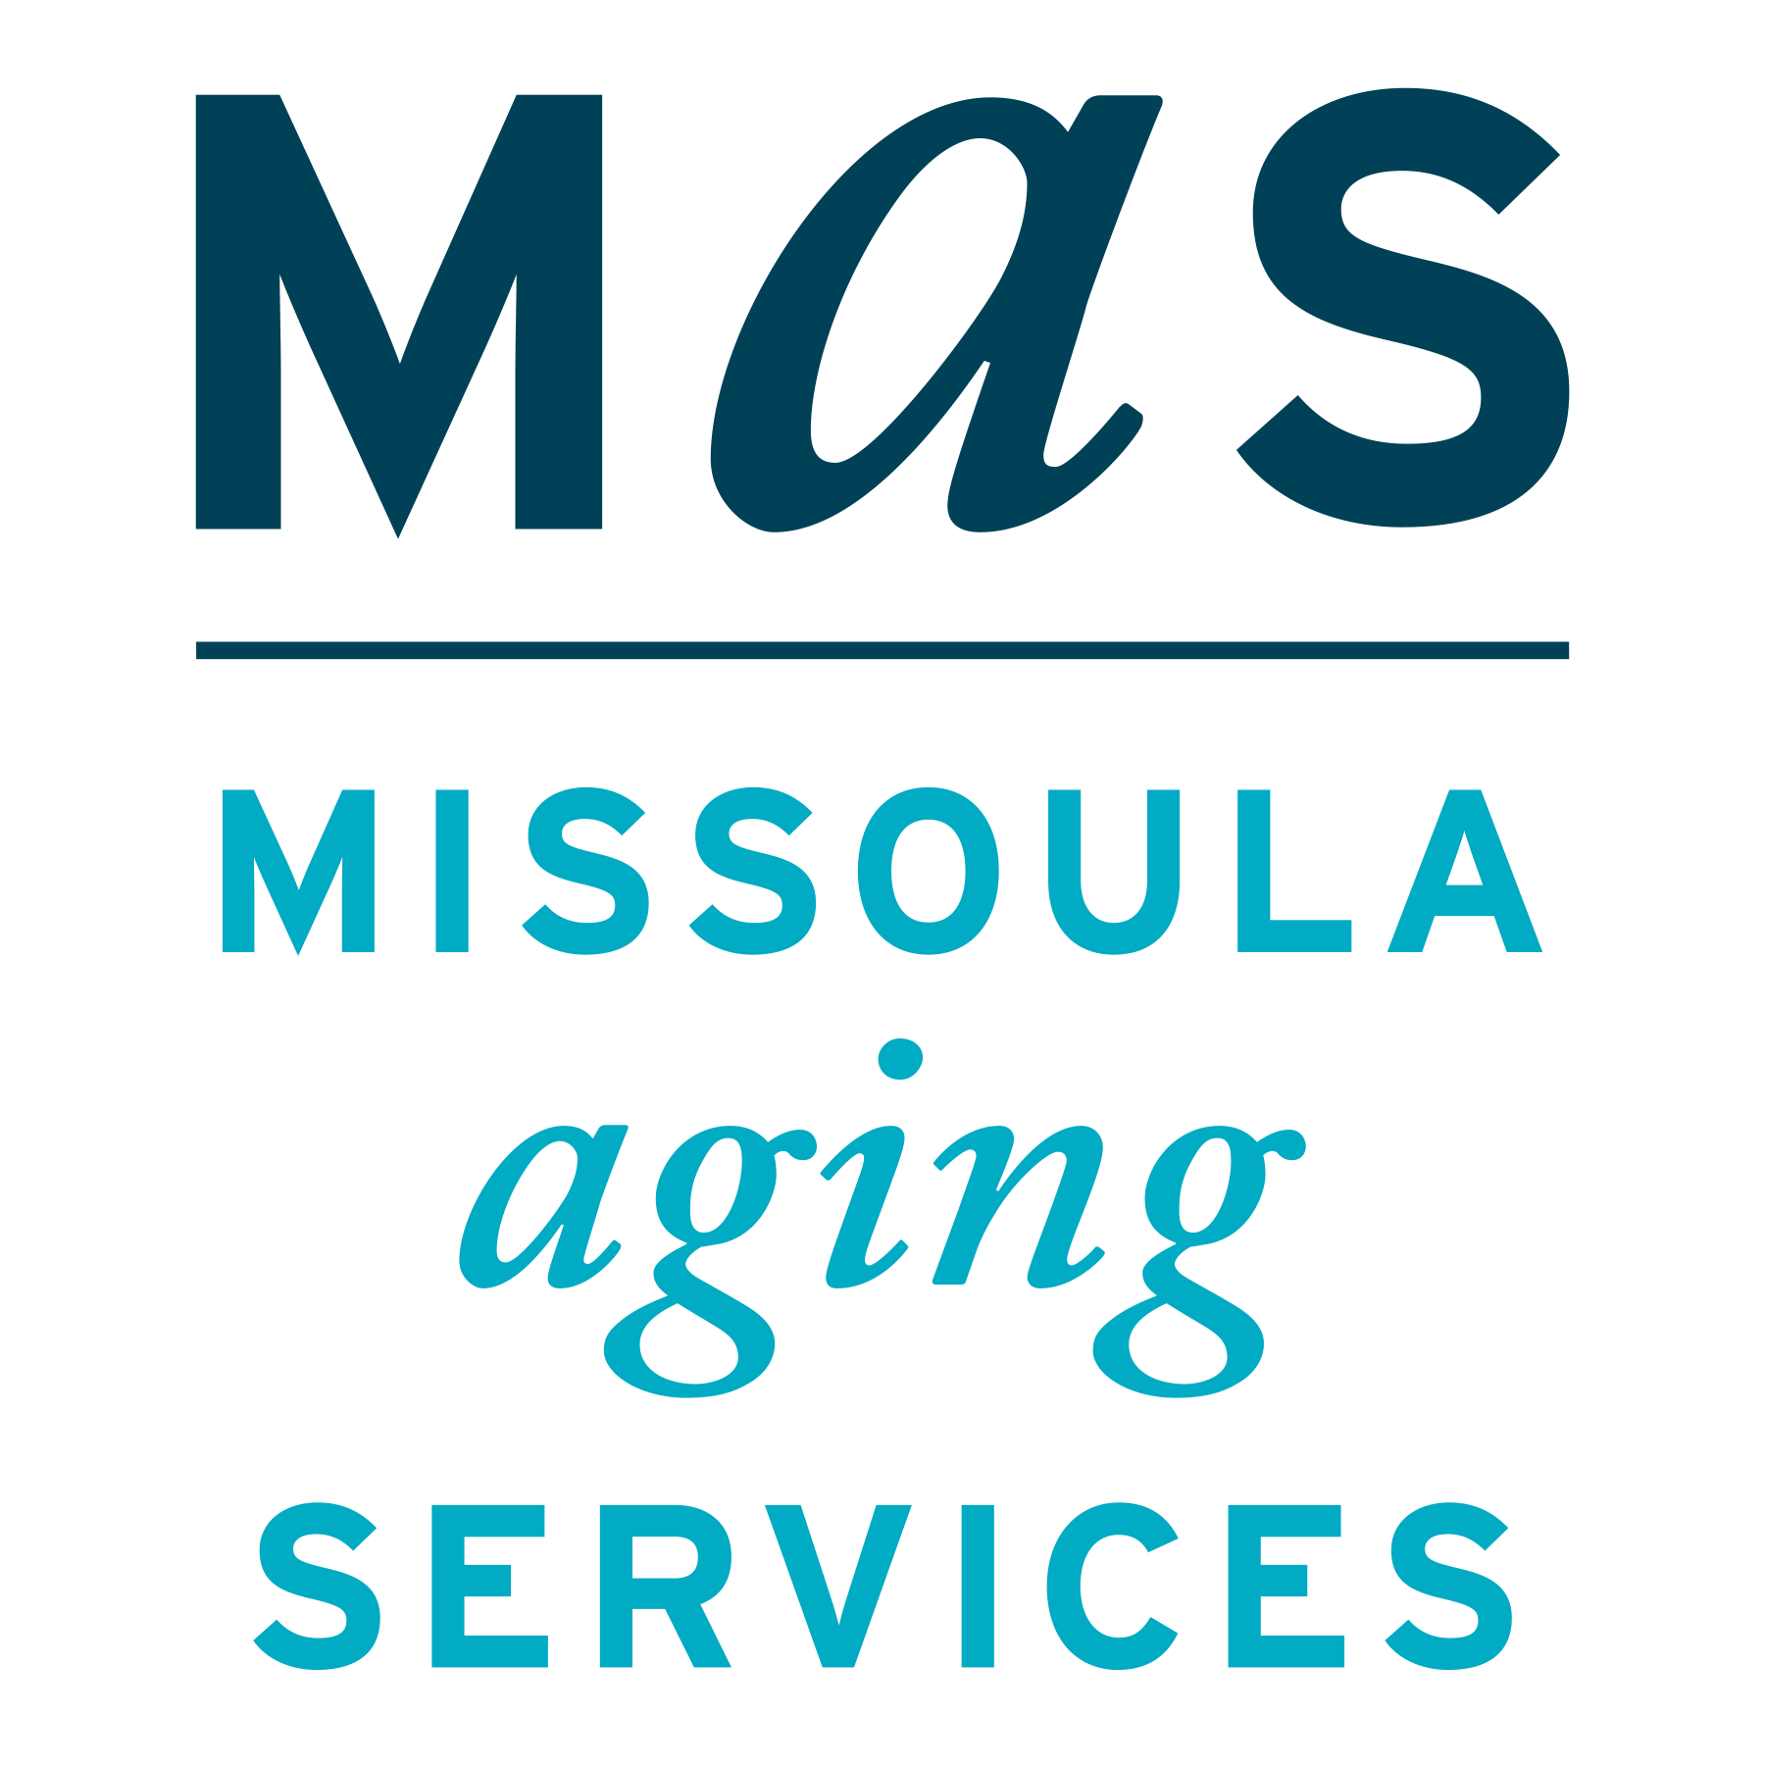



Montana SMP is a program coordinated by Missoula Aging Services and partnered with local Area Agencies on Aging. This project was supported by grant #90MPPG0052 from the U.S. Administration for Community Living, Department of Health and Human Services, Washington D.C., 20201. Points of view or opinions do not necessarily represent official ACL policy.

The Senior Medicare Patrol (SMP) helps to educate Medicare beneficiaries about ways to prevent, detect, and combat Medicare fraud. For more information about Medicare fraud, visit the Stop Medicare Fraud website at www.stopmedicarefraud.org.

