**‘Care Share**



April 2022

Attention Medicaid consumers: Renewals are coming back. Many were paused due to COVID19. It is very important that the Montana Medicaid office knows where to send your Medicaid renewal letter. If you or your family member moved, **please make sure Montana Medicaid has your address, email, and phone number!** If not, it can slow down the process and possibly result in a pause in benefits.

This renewal letter will tell you one of three things:

1. MT Medicaid is renewing your Medicaid coverage, or
2. MT Medicaid is ending your Medicaid coverage, or
3. MT Medicaid needs more information to determine if you or your family member still qualify for Medicaid. If so, a renewal form will be included.

**Updates from CMS**

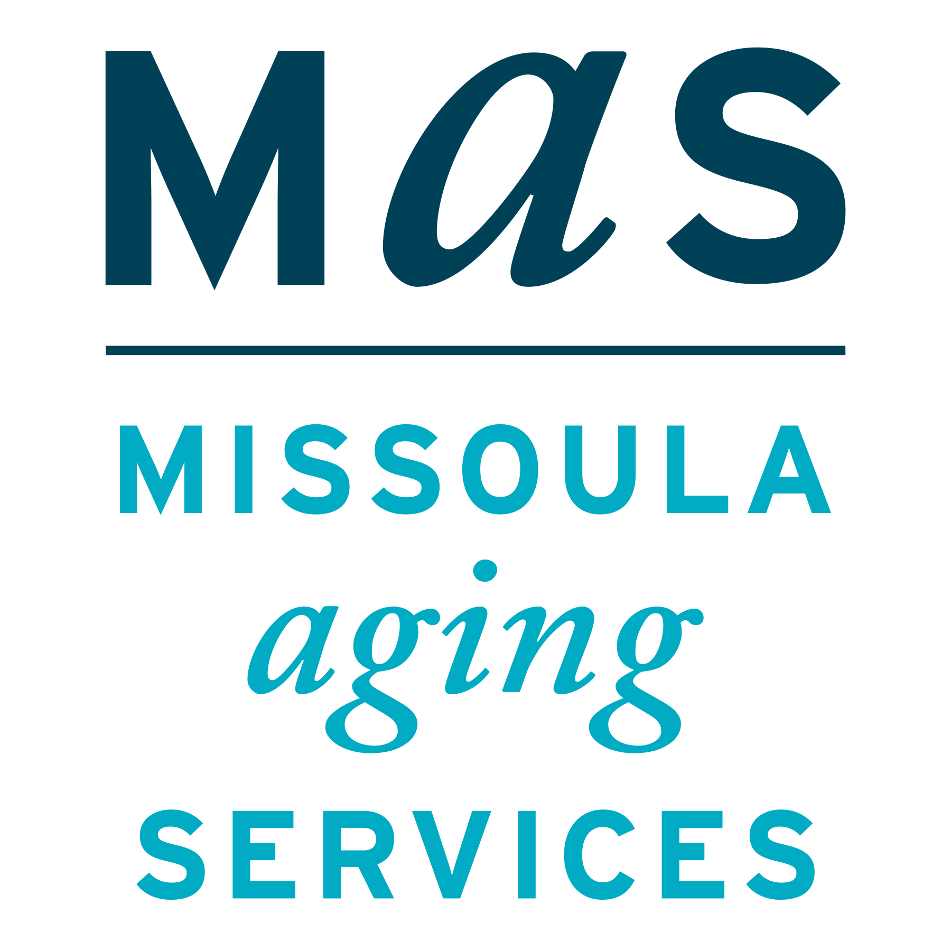



Montana SMP is a program coordinated by Missoula Aging Services and partnered with local Area Agencies on Aging. This project was supported by grant #90MPPG0052 from the U.S. Administration for Community Living, Department of Health and Human Services, Washington D.C., 20201. Points of view or opinions do not necessarily represent official ACL policy.

**Limited Availability of Equitable Relief - Medicare Enrollment/Disenrollment**

Recent systemic technical issues surrounding SSA’s National 800 Network Number and Field Office general inquiry phone lines may have caused difficulties for some beneficiaries attempting to contact SSA, including those seeking to submit Medicare enrollment or disenrollment requests. Therefore, anyone who was unable to enroll due to SSA’s telephone issues after January 1, 2022, will be granted additional time, through December 30, 2022, to enroll.

Given recent technical issues, CMS is providing equitable relief to beneficiaries who could not submit premium-Part A or Part B enrollment or disenrollment requests timely. This relief applies to the 2022 General Enrollment Period (GEP), Initial Enrollment Period (IEP), and Special Enrollment Period (SEP).

Beginning April 1, 2022, equitable relief will be determined on a case-by-case basis for beneficiaries who allege difficulties submitting timely 2022 GEP, IEP, or SEP enrollment requests via phone and fax.

This consideration of equitable relief ends December 30, 2022. If you need assistance, call your local SHIP in Montana at 1-800-551-3191.

**Eligible Individuals Can Receive Second COVID-19 Booster Shot at No Cost**

On April 6, CMS announced it will pay for a second COVID-19 booster shot of either the Pfizer-BioNTech or Moderna COVID-19 vaccines without cost sharing, as it continues to provide coverage for this critical protection from the virus. People with Medicare pay nothing to receive a COVID-19 vaccine, and there is no applicable copayment, coinsurance, or deductible. People with Medicaid coverage can also get COVID-19 vaccines, including boosters, at no cost.

The CDC recently updated its recommendations regarding COVID-19 vaccinations. Certain immunocompromised individuals and people ages 50 years and older who received an initial booster dose at least 4 months ago are eligible for another booster to increase their protection against severe disease from COVID-19. Additionally, the CDC recommends that adults who received a primary vaccine and booster dose of Johnson & Johnson’s Janssen COVID-19 vaccine at least 4 months ago can receive a second booster dose of a Pfizer-BioNTech or Moderna COVID-19 vaccine.

The Senior Medicare Patrol (SMP) helps to educate Medicare beneficiaries about ways to prevent, detect, and combat Medicare fraud. For more information about Medicare fraud, visit the Stop Medicare Fraud website at www.stopmedicarefraud.org.

