**‘Care Share**

**May 2022**

Scams evolve over time. Trying to keep up with the latest attempts to get your money or personal information may be downright impossible. However, there are still ways to ensure you don’t fall victim without feeling like you need to know what the scams are ahead of time.

Scams target everyone. Therefore, you can be almost certain that if you’ve come across a scam, it’s already known by others as well. Instead of feeling overwhelmed in trying to keep up with latest scams, use this to your advantage.

Most scams succeed because they look like the real thing and try to catch you off guard when you’re not expecting it. Be alert to the fact that scams exist and when you receive an uninvited contact from people or businesses whether it is by mail, email, social media, or over the phone, be empowered to check on them.

Your first step is to write down or collect any information including name, phone number, address, etc.

The next step is to look them up, whether it’s someone telling you that Medicare is sending a new plastic card, that they have money to give you but first you need to pay a fee, mail them a prepaid debit card, or that there is a warrant for your arrest. Open your internet browser, aka search engine, aka Google, Internet Explorer, Firefox, etc., and search for them.

Use any relevant details and the word scam and see what turns up first. “Medicare plastic card scam”, Medicare chip card scam”, “jury duty warrant scam”, “Social Security scam”, “mail debit card scam”. You get the picture. If needed, also search for the company name or phone number. If it is a legitimate business, their information will be easy to find.

By taking this one simple step, you can stop scams in their tracks regardless of what the newest version is. If you need help, call a friend, family member, or a trusted source like your local Office on Aging, and never feel like an uninvited contact has control over you again.

Montana SMP is a program coordinated by Missoula Aging Services and partnered with local Area Agencies on Aging. This project was supported by grant #90MPPG0052 from the U.S. Administration for Community Living, Department of Health and Human Services, Washington D.C., 20201. Points of view or opinions do not necessarily represent official ACL policy.

**You Can Find the Scams**

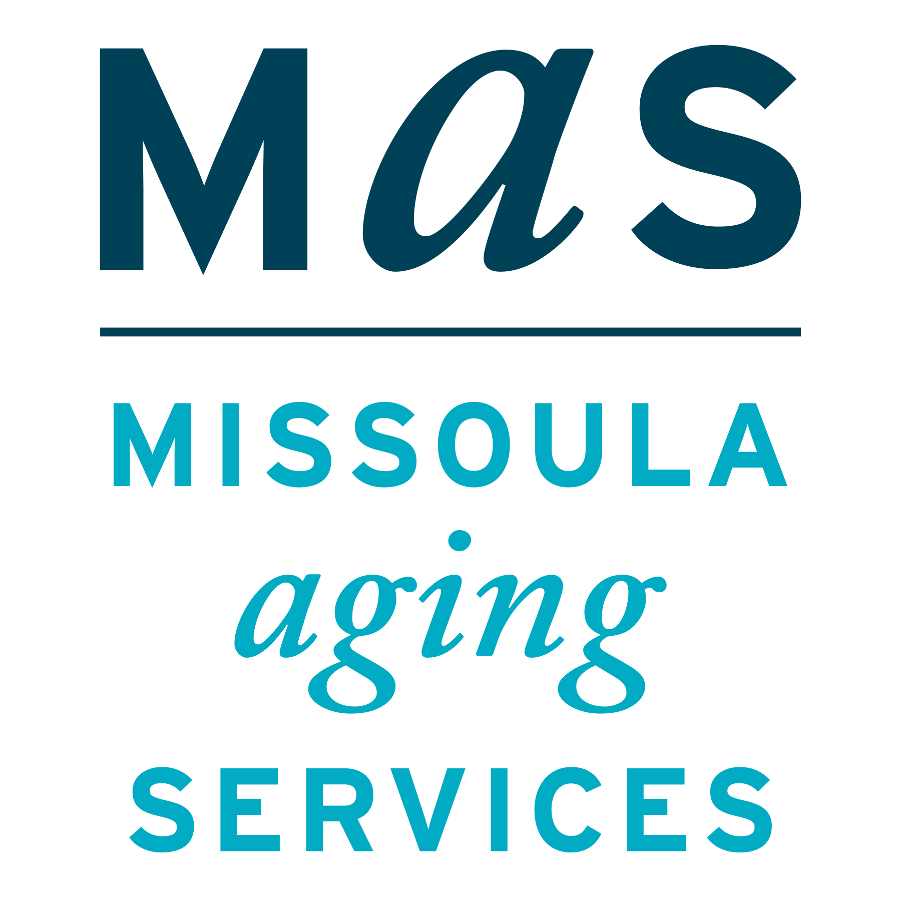

The Senior Medicare Patrol (SMP) helps to educate Medicare beneficiaries about ways to prevent, detect, and combat Medicare fraud. For more information about Medicare fraud, visit the Stop Medicare Fraud website at www.stopmedicarefraud.org.

While not answering numbers you don't know is the best choice, scammers are tricky, and you might answer thinking it is someone else. When you get these calls, just hang up. This is the safest way to avoid giving out personal or financial information.

If you did give out personal information and are concerned you’ve been scammed, call your closest SMP office in Montana at 1-800-551-3191.